VA Eligibility & Benefits Tracking System
Forest Wadsworth
CST-451 Capstone Project Final Architecture & Design
Grand Canyon University
Instructor: Professor Donna Jackson
Revision: 1.0
June 14, 2026

ABSTRACT

The VA Benefits Eligibility and Tracking System is a web-based application designed to assist veterans and other users in understanding potential eligibility for Veterans Affairs (VA) benefits and monitoring the status of benefit claims through a centralized platform. The purpose of this project is to simplify access to benefit-related information by providing a user-friendly system that consolidates eligibility evaluation and claim tracking functionality into a single application. Many veterans face challenges navigating complex eligibility requirements and fragmented information sources. This project addresses that problem by providing an intuitive interface that guides users through the process of entering military service information, reviewing simulated eligibility determinations, and tracking claim progress.
The system was designed using a layered architecture that separates the presentation, business logic, and data access layers to improve maintainability, scalability, and security. The proposed solution utilizes Java, Spring Boot, MySQL, RESTful APIs, and modern web development technologies to support core application functionality. Key design artifacts developed during the project include system architecture diagrams, deployment diagrams, activity diagrams, an Entity Relationship Diagram (ERD), UML class and sequence diagrams, wireframes, API specifications, and database design documentation. These artifacts provide a comprehensive blueprint for system implementation and ensure consistency across all components of the design.
The completed architecture and design establish a strong technical foundation for future development of the application. The design incorporates security controls, database integrity constraints, operational support considerations, and non-functional requirements related to performance, reliability, usability, and maintainability. By completing the requirements analysis and design phases prior to implementation, the project reduces development risk and provides a clear roadmap for building a functional VA Benefits Eligibility and Tracking System during subsequent project milestones. This solution demonstrates the application of software engineering principles and industry best practices to address a real-world problem while remaining achievable within the scope of the capstone project.

History and Signoff Sheet
Change Record
Date | Author | Revision Notes
 |  | Initial draft for review/discussion

Overall Instructor Feedback/Comments

Overall Instructor Feedback/Comments
Integrated Instructor Feedback into Project Documentation
☐ Yes ☐ No

TABLE OF CONTENTS
Design Overview 4
Detailed High-Level Solution Design 5
Detailed Technical Design 6
Appendix A – Technical Issue and Risk Log 7
Appendix B – References 8
Appendix C – External Resources 9

Design Introduction
The VA Benefits Eligibility and Tracking System is a web-based application designed to provide veterans and other users with a centralized platform for evaluating simulated Veterans Affairs (VA) benefit eligibility and monitoring claim statuses. The system was developed to address the challenge of navigating fragmented information sources and complex eligibility requirements by consolidating essential benefit-related functions into a single, user-friendly application.
The application allows authenticated users to create accounts, securely log into the system, submit military service information, and receive simulated eligibility determinations based on predefined business rules. Eligibility results are presented through a dashboard that also provides claim tracking functionality, allowing users to view the status of simulated claims and monitor progress updates. By centralizing these functions, the system improves organization, accessibility, and overall usability while demonstrating modern software engineering practices.
The proposed solution utilizes a layered architecture consisting of a presentation layer, business logic layer, and data layer. Users interact with the system through a browser-based interface developed using standard web technologies. Requests are processed through a Spring Boot backend that manages authentication, eligibility processing, business rules, and database interactions. Data persistence is provided through a MySQL relational database that stores user account information, service records, eligibility results, and claim data.

The high-level workflow of the application follows the sequence below:
- User accesses the application through a web browser.
- User registers for an account or authenticates using existing credentials.
- User submits military service information through a structured form.
- The system validates submitted information.
- Eligibility processing logic evaluates user data against predefined rules.
- Results are stored in the database.
- The dashboard displays eligibility outcomes and claim information.
- Users may update information and re-evaluate eligibility as needed.
- Users securely log out of the application.

User Interface Overview
The application provides several primary user interfaces that support the core functionality of the system. These interfaces include a login screen for authentication, a registration screen for account creation, a service information form for collecting military service details, and a user dashboard that displays eligibility results and claim tracking information. Detailed wireframes and interface diagrams are provided in the User Interface Diagrams section of this document.

Anticipated Process Flow

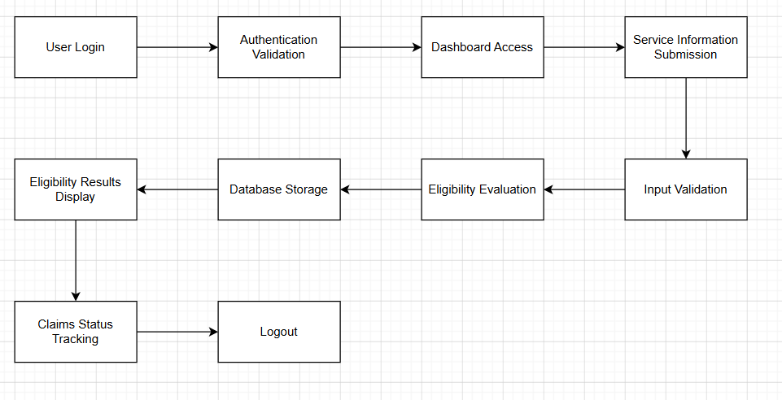

The purpose of this design is to establish a clear architectural blueprint that supports application development, testing, maintenance, and future enhancement while ensuring alignment with project requirements and stakeholder expectations.

Stakeholders
The primary stakeholder for this project is the course instructor, who serves as the project evaluator and approves project deliverables throughout the development lifecycle. Additional stakeholders include prospective users of the system, such as veterans seeking a simplified method of understanding benefits eligibility and tracking claim information.

Stakeholder | Role | Responsibility
Forest Wadsworth | Developer | Design, develop, test, and document the application
Professor Donna Jackson | Instructor / Evaluator | Review deliverables and assess project completion
End Users (Veterans) | System Users | Utilize the application to view eligibility and claim information

Project Deliverables
The following deliverables support the design, implementation, testing, and final submission of the VA Benefits Eligibility and Tracking System:
- Project Proposal
- Requirements Specification Document
- Architecture and Design Document
- Source Code Repository
- Database Schema and DDL Scripts
- UML Diagrams
- User Interface Designs
- REST API Documentation
- Testing Documentation
- Final Project Presentation
- Completed Web Application

Deliverable Acceptance Log

ID | Deliverable Description | Comments | Evaluator | Status | Date of Decision
1 | Project Proposal | Approved project scope and objectives | Instructor | Complete | Week 1
2 | Requirements Specification Document | Defined functional and non-functional requirements | Instructor | Complete | Week 3
3 | Architecture and Design Document | Defines system architecture and technical design | Instructor | In Progress | TBD
4 | Application Source Code and Database Implementation | Functional implementation of system requirements | Instructor | In Progress | TBD
5 | Final Capstone Submission and Presentation | Final project delivery and demonstration | Instructor | Pending | TBD

Detailed High-Level Solution Design

1.1 Overview of System Design Integration
The VA Benefits Eligibility and Tracking System is designed as a modular web-based application that follows a layered architecture pattern to ensure separation of concerns, scalability, and maintainability. The proposed design integrates user interaction, business processing, and data persistence into a unified system that simulates VA benefits eligibility determination and claim tracking.
The system fits into the overall solution by dividing responsibilities into clearly defined components: a presentation layer for user interaction, a business logic layer for processing eligibility rules and application workflows, and a data layer for persistent storage. This separation allows each layer to evolve independently while maintaining structured communication through defined interfaces.

1.2 Logical System Architecture (Component View)
The logical architecture of the system can be represented using the following component structure:
User Interface Layer
- Login Interface
- Registration Interface
- Service Information Form
- Dashboard Interface
Application Layer (Spring Boot Backend)
- Authentication Controller
- Eligibility Processing Service
- Claim Tracking Service
- User Service Layer
- REST API Controllers
Data Layer
- User Database Table
- Service Information Table
- Eligibility Results Table
- Claims Table

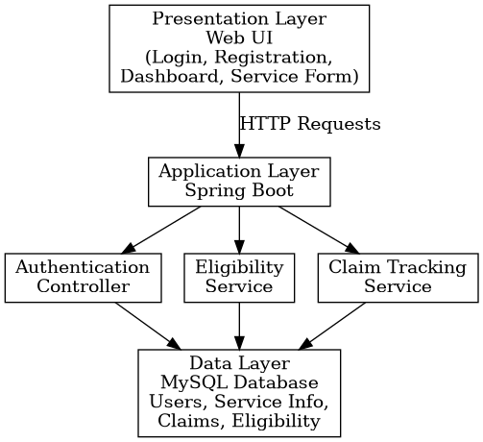

1.3 Physical Architecture (Deployment View)
The physical deployment of the system is designed as a standard client-server model:
- Client Device
  - Web browser used by end users (Chrome, Edge, Firefox)
- Application Server
  - Spring Boot application hosted locally during development
  - Handles REST API requests and business logic processing
- Database Server
  - MySQL database instance for persistent storage

1.4 UML Activity Diagram (Process Flow)
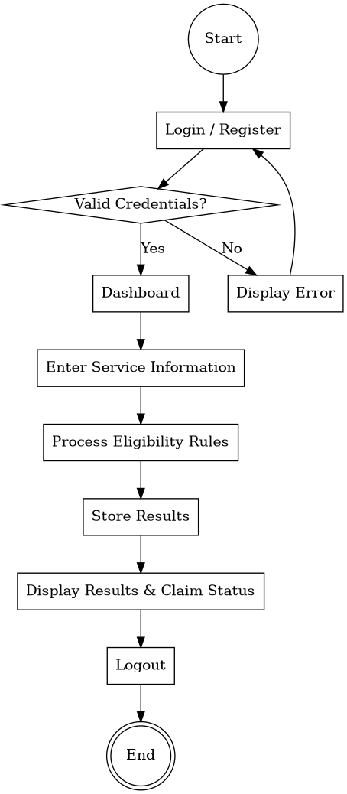
The primary system workflow follows this activity sequence:

1.5 Solution Configuration Requirements
The following configuration settings are required to support development and implementation of the system:
- Backend Configuration
  - Spring Boot application configured with embedded Tomcat server
  - RESTful API endpoints enabled using Spring Web dependency
  - Application properties configured for database connectivity
- Database Configuration
  - MySQL schema created for VA Benefits System
  - JDBC connection configured in application properties
  - ORM mapping using Spring Data JPA
- Frontend Configuration
  - Static HTML/CSS/JavaScript structure
  - API communication through HTTP requests (Fetch/AJAX)
- Development Environment Setup
  - Java JDK 17 or higher
  - Maven dependency management
  - Git version control system

1.6 Non-Functional Requirements Strategy
Security
The system will implement security measures to ensure protected access and data integrity:
- Authentication required for system access
- Planned encrypted password storage (BCrypt)
- Input validation to prevent malicious or invalid data
- Secure API endpoint design (future implementation using Spring Security)
Performance
Performance requirements will be addressed through:
- Lightweight REST API design
- Efficient database queries using indexed tables
- Minimal data transfer between frontend and backend
Reliability
Reliability will be ensured through:
- Modular service design for fault isolation
- Structured exception handling approach
- Database constraints for data consistency
Maintainability
Maintainability is achieved through:
- Layered architecture separation
- Modular service classes
- Clear separation of UI, business logic, and data layers
- RESTful API structure for scalable development

1.7 Purpose of Architecture Design
The purpose of this high-level architecture design is to provide sufficient technical detail to guide system implementation in later development phases. It defines how system components interact, how data flows between layers, and how the system will be structured to meet both functional and non-functional requirements.
This design ensures that developers can implement the system in a structured and scalable manner while maintaining alignment with academic project requirements and software engineering best practices.

Proof of Concepts (POC)
A Proof of Concept (POC) is a small-scale validation activity performed to determine whether a selected technology, framework, or design approach is suitable before full implementation. The following POCs are planned to reduce technical risk and verify that selected technologies can support the requirements of the VA Benefits Eligibility and Tracking System.

Description | Rationale | Expected Results
Spring Boot Application Framework | Validate the selected backend framework for developing RESTful services and business logic components. | Confirm that Spring Boot supports the required architecture and simplifies application development.
MySQL Database Design | Verify that a relational database structure can effectively store users, service information, eligibility results, and claim records. | Confirm that the proposed schema supports data integrity and future scalability.
Authentication and Authorization Design | Evaluate methods for securing user accounts and restricting access to protected resources. | Identify a secure authentication strategy suitable for the application.
Eligibility Rule Processing Logic | Validate that service-related data can be evaluated using rule-based processing logic. | Confirm that simulated eligibility determinations can be generated consistently and accurately.
REST API Communication | Verify communication between the frontend interface and backend services using RESTful APIs. | Confirm that user requests and system responses can be exchanged efficiently.

Hardware and Software Technologies
The VA Benefits Eligibility and Tracking System will utilize a combination of software frameworks, development tools, and database technologies to support application development, testing, and deployment.

Hardware Requirements

Development Environment
- Personal Computer or Laptop
- Minimum 8 GB RAM
- Multi-Core Processor
- Internet Connection for Development Resources and Version Control

Deployment Environment (Planned)
- Application Server capable of running Java applications
- Database Server running MySQL
- Network connectivity for client access

Software Technologies
Technology | Purpose
Java (JDK 17+) | Primary programming language used for backend development
Spring Boot | Backend application framework
Spring Web | REST API development
Spring Data JPA | Data persistence and database interaction
MySQL | Relational database management system
Hibernate | Object-relational mapping framework
HTML5 | User interface structure
CSS3 | User interface styling
JavaScript | Client-side functionality
Maven | Dependency management and build automation
Git | Version control
GitLab | Source code repository and project management
Postman | API testing and validation
Draw.io | System and UML diagram creation

Frameworks and Third-Party Libraries
The following frameworks and libraries are planned for use within the project:

Spring Boot Framework
Spring Boot serves as the primary application framework and provides rapid development capabilities, embedded server support, dependency management integration, and simplified application configuration.

Spring Data JPA
Spring Data JPA will be used to simplify database operations by reducing boilerplate code and providing repository-based data access patterns.

Hibernate
Hibernate will act as the Object Relational Mapping (ORM) framework responsible for mapping Java objects to relational database tables.

Maven
Maven will manage project dependencies, build processes, and application packaging.

BCrypt Password Encoder (Planned)
BCrypt may be utilized to securely hash user passwords before storage in the database, helping protect sensitive user credentials.

Technology Selection Justification
The selected technologies were chosen based on their widespread industry adoption, extensive documentation, compatibility with course objectives, and ability to support the functional and non-functional requirements identified during requirements analysis.
The Spring Boot ecosystem provides a complete framework for developing enterprise web applications while integrating seamlessly with MySQL and modern RESTful API architectures. The selected technology stack also aligns with the developer's existing knowledge and coursework, reducing implementation risk while maximizing development efficiency.

Logical Solution Design
The logical solution design illustrates how the software components of the VA Benefits Eligibility and Tracking System interact to support user authentication, eligibility determination, claim tracking, and data management. The system follows a layered architecture that separates presentation, business logic, and data access responsibilities.


Figure 4. Logical Architecture Diagram
Figure 4 illustrates the relationship between the Presentation Layer, Application Layer, and Data Layer. User requests originate from the web interface and are routed through REST API controllers to the service layer, where business rules are executed. Data persistence is managed through repository components that communicate with the MySQL database.

Presentation Layer
The Presentation Layer provides the user-facing interfaces of the application. This layer is responsible for collecting user input and displaying application data. Major interfaces include:
- Login Page
- Registration Page
- Dashboard
- Service Information Form
- Claim Tracking View

Application Layer
The Application Layer contains the core business logic of the system and consists of the following components:

Authentication Module
The Authentication Module is responsible for:
- User registration
- Login processing
- Credential validation
- Session management
- Access control enforcement

Eligibility Processing Module
The Eligibility Processing Module evaluates user-provided military service information against predefined eligibility rules. This component simulates the decision-making process used to determine qualification for various VA benefits.
Responsibilities include:
- Service information validation
- Eligibility rule execution
- Benefits determination
- Eligibility result generation

Claim Tracking Module
The Claim Tracking Module manages claim-related information and provides users with visibility into claim status updates.
Responsibilities include:
- Claim record creation
- Status management
- Claim history retrieval
- Dashboard integration

User Management Module
The User Management Module supports account maintenance functions such as profile management and service information updates.

Data Layer
The Data Layer is responsible for storing and retrieving all persistent application data. This layer provides a centralized repository for information generated and maintained by the system.
Planned database entities include:

User
Stores account information including:
- User ID
- Username
- Email Address
- Password Hash
- Account Status

Service Information
Stores military service-related data including:
- Branch of Service
- Service Start Date
- Service End Date
- Discharge Status
- Disability Rating

Eligibility Results
Stores generated eligibility determinations including:
- Eligibility ID
- User ID
- Benefit Type
- Eligibility Status
- Evaluation Date

Claims
Stores claim tracking information including:
- Claim ID
- User ID
- Claim Type
- Claim Status
- Submission Date
- Last Updated Date

Logical Data Flow
The logical flow of information through the system follows the sequence below:
- User submits a request through the web interface.
- The request is sent to the appropriate controller within the application layer.
- Business services validate and process the request.
- Required information is retrieved from or stored in the database.
- The application generates a response.
- Results are returned to the user interface for display.
This layered flow ensures that user interaction, business processing, and data management remain separated while supporting efficient communication between system components.

Logical Architecture Benefits
The selected logical architecture provides several advantages:
- Separation of concerns between system layers
- Improved maintainability through modular design
- Easier testing and debugging
- Greater scalability for future enhancements
- Improved security through centralized processing and validation
- Reduced coupling between components
The logical design serves as the foundation for system implementation and provides a blueprint that developers can use when constructing application components during future development phases.

Physical Solution Design
The physical solution design describes how the components of the VA Benefits Eligibility and Tracking System will be deployed and interact within the operating environment. While the logical design focuses on software functionality and data flow, the physical design focuses on the hardware, software platforms, and communication pathways that support application execution. The proposed solution follows a standard three-tier client-server architecture consisting of a client device, application server, and database server.

Figure 5. Physical Deployment Diagram
The deployment architecture is designed to support secure communication between users and application resources while maintaining a clear separation between presentation, business logic, and data storage components. User requests originate from a client device and are transmitted to the application server through standard web protocols. The application server processes requests, executes business logic, and communicates with the database server when persistent data storage or retrieval is required.

Client Device Layer
The client layer represents the end user's device and serves as the primary access point to the application. Users interact with the system through a modern web browser without requiring additional software installation.
Responsibilities of the client layer include:
- Displaying user interface components
- Collecting user input
- Sending requests to the application server
- Displaying eligibility results and claim information
- Managing basic client-side navigation
Supported client devices may include:
- Desktop computers
- Laptop computers
- Tablets
- Mobile devices with modern web browsers
Because the application is browser-based, users can access the system from multiple device types without platform-specific installation requirements.

Application Server Layer
The application server hosts the backend components of the VA Benefits Eligibility and Tracking System. This layer is responsible for executing business logic, processing user requests, managing authentication, and coordinating communication between the presentation and data layers.
The planned application server environment includes:
- Java Runtime Environment (JRE)
- Spring Boot Framework
- Embedded Tomcat Server
- REST API Services
- Business Logic Components
Major responsibilities include:
- Processing authentication requests
- Executing eligibility determination logic
- Managing claim tracking functionality
- Validating user input
- Retrieving and storing application data
The application server acts as the central processing component of the system and serves as the primary integration point between users and stored data.

Database Server Layer
The database layer provides persistent storage for all application information. A MySQL relational database management system will be used to store and manage user accounts, military service information, eligibility determinations, and claim tracking records.
Planned database entities include:
- Users
- Service Information
- Eligibility Results
- Claims
The database server is responsible for:
- Data storage and retrieval
- Maintaining data integrity
- Enforcing relational constraints
- Supporting application queries
- Preserving application state between user sessions
Separating the database from the application server improves maintainability and supports future scalability.

Network Communication
Communication between system components will occur using standard web technologies and protocols.

Client to Application Server
Communication between users and the application server will occur through HTTP or HTTPS requests. User actions such as login, registration, service information submission, and claim tracking requests will be transmitted through RESTful API endpoints exposed by the backend application.

Application Server to Database Server
Communication between the application server and database server will occur through JDBC connections managed by Spring Data JPA. This allows backend services to perform Create, Read, Update, and Delete (CRUD) operations while maintaining abstraction from direct database implementation details.

Scalability and Future Deployment Considerations
Although the initial project implementation is designed for development and demonstration purposes, the physical architecture supports future expansion. Potential enhancements include:
- Deployment to cloud platforms such as AWS or Azure
- Containerization using Docker
- Dedicated database hosting
- Load balancing for increased traffic
- Secure HTTPS deployment with SSL certificates
The selected architecture provides a flexible foundation that can support future enhancements while remaining appropriate for the scope of the capstone project.

Physical Design Summary
The physical solution design establishes a clear deployment model that separates client access, application processing, and data storage into distinct layers. This structure improves maintainability, supports secure communication, and provides a scalable foundation for future development. By following a standard client-server architecture, the system remains aligned with industry best practices while satisfying the functional and non-functional requirements defined for the VA Benefits Eligibility and Tracking System.

Detailed Technical Design

General Technical Approach:
The development of the VA Benefits Eligibility and Tracking System follows a structured software engineering approach that emphasizes maintainability, scalability, security, and ease of future enhancement. The system is designed as a web-based application that provides users with a centralized platform for evaluating simulated VA benefits eligibility and tracking claim information through an intuitive user interface.
A layered architecture was selected as the foundation of the design because it promotes separation of concerns between presentation, business logic, and data management components. This architectural approach allows each layer to be developed, tested, and maintained independently while supporting efficient communication between system components. By separating responsibilities, the design reduces system complexity and improves long-term maintainability.
During the planning and requirements phases of the project, significant effort was devoted to identifying the core functionality required to support the application's objectives. User stories, functional requirements, non-functional requirements, wireframes, UML diagrams, and database models were developed to establish a clear understanding of system behavior before implementation begins. These design artifacts were continuously reviewed and refined to ensure consistency across all aspects of the solution.
The application is designed around several core functional areas, including user authentication, military service information management, eligibility determination, and claim tracking. These features are supported by a relational database structure designed to store user accounts, service records, eligibility results, and claim information. Business logic components will process user-submitted data and apply predefined eligibility rules to generate simulated benefit determinations.
Security considerations were incorporated early in the design process. Authentication mechanisms, secure credential storage, input validation, and controlled access to application resources are planned to help protect user data and maintain system integrity. Although the application utilizes simulated VA data and does not interact with official government systems, the design follows security best practices commonly used in enterprise web applications.
The development process will follow an incremental implementation approach. Core infrastructure components such as project configuration, database connectivity, authentication, and entity models will be developed first. Additional functionality, including eligibility processing, claim tracking, and dashboard features, will then be built upon this foundation. This approach reduces implementation risk and allows individual system components to be validated before more advanced functionality is introduced.
The overall goal of the technical design is to provide a clear blueprint that guides implementation while ensuring the system remains aligned with the requirements established during earlier project phases. The resulting architecture provides a framework that supports both current project objectives and future enhancements.

Key Technical Design Decisions:
Several key technical decisions were made during the design phase of the VA Benefits Eligibility and Tracking System. These decisions were based on project requirements, anticipated system functionality, ease of development, industry best practices, and compatibility with the technologies studied throughout the software development program.
Technology / Design Decision | Purpose | Rationale for Selection
Layered Architecture | Separates presentation, business logic, and data access responsibilities | Improves maintainability, scalability, and separation of concerns while reducing system complexity
Java | Primary programming language | Provides strong object-oriented capabilities, extensive documentation, and compatibility with enterprise application development
Spring Boot | Backend application framework | Simplifies application configuration, supports REST API development, and integrates well with database technologies
RESTful API Architecture | Communication between frontend and backend components | Provides a standardized and scalable approach for exchanging data between system layers
MySQL | Relational database management system | Reliable, widely used, cost-effective, and well suited for structured relational data storage
Spring Data JPA | Data access framework | Reduces boilerplate code and simplifies interaction with database entities
Hibernate ORM | Object-relational mapping framework | Simplifies database persistence and object mapping while improving developer productivity
HTML, CSS, and JavaScript | User interface development | Industry-standard technologies for creating browser-based web applications
Maven | Dependency management and build automation | Simplifies project configuration, dependency management, and application packaging
Git/GitLab | Version control and project management | Supports source code management, issue tracking, collaboration, and change history
BCrypt Password Encryption (Planned) | Secure password storage | Protects user credentials by storing hashed passwords instead of plain-text values

Architecture Selection
A layered architecture was selected because it promotes clear separation between user interface components, business processing logic, and data management operations. This design approach simplifies maintenance and supports future expansion by reducing dependencies between application components.

Framework Selection
Spring Boot was selected as the primary application framework because it provides extensive support for web application development, dependency injection, RESTful services, security integration, and database connectivity. The framework also aligns closely with technologies covered throughout the software development curriculum.

Database Selection
MySQL was chosen as the database platform because it provides a reliable and efficient solution for managing structured relational data. The application's entities, including users, service information, eligibility results, and claims, naturally fit within a relational database model.

API Design Approach
RESTful APIs were selected as the communication mechanism between the frontend and backend layers. REST provides a lightweight and standardized approach for exchanging data while supporting future integration opportunities if additional clients or services are introduced.

Security Considerations
Although implementation has not yet begun, security requirements influenced several design decisions. Planned security measures include user authentication, encrypted password storage, input validation, controlled access to protected resources, and secure handling of user-submitted information.

Design Decision Summary
The selected technologies and architectural patterns were chosen because they provide a balance between functionality, maintainability, scalability, and ease of implementation. Collectively, these decisions establish a strong technical foundation that supports the project requirements while remaining achievable within the scope of the capstone project.

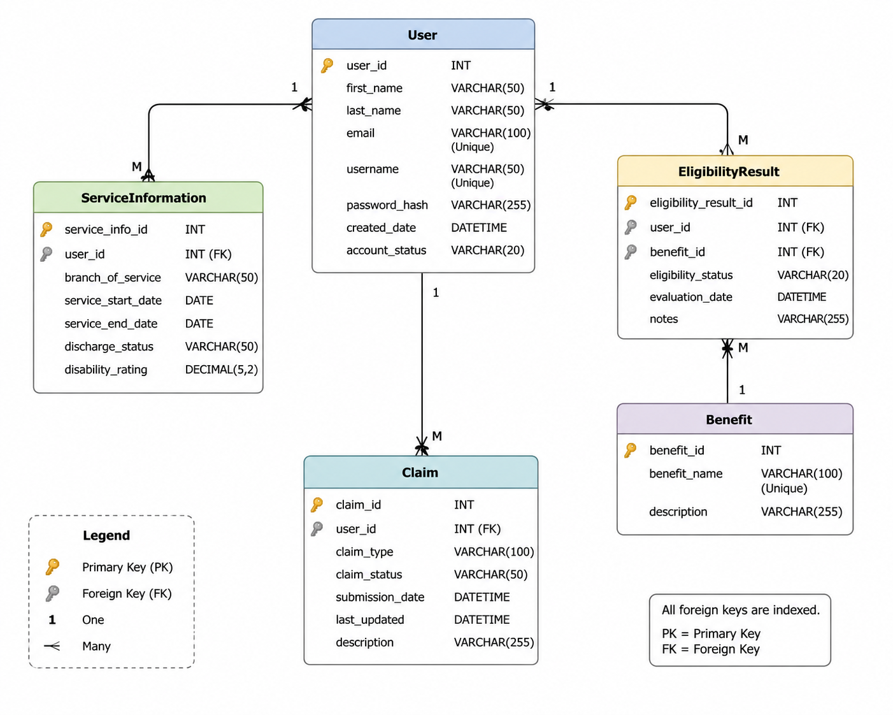
Database ER Diagram:

Database DDL Scripts:
The following Data Definition Language (DDL) scripts define the database structure for the VA Benefits Eligibility and Tracking System. These scripts create the tables, primary keys, foreign key relationships, and constraints necessary to support user management, military service information, eligibility evaluations, and claim tracking functionality.
The database design follows a relational model that promotes data integrity, minimizes redundancy, and supports efficient querying through properly defined relationships and constraints.

User Table
CREATE TABLE User (
user_id INT AUTO_INCREMENT PRIMARY KEY,
first_name VARCHAR(50) NOT NULL,
last_name VARCHAR(50) NOT NULL,
email VARCHAR(100) NOT NULL UNIQUE,
username VARCHAR(50) NOT NULL UNIQUE,
password_hash VARCHAR(255) NOT NULL,
created_date DATETIME NOT NULL DEFAULT CURRENT_TIMESTAMP,
account_status VARCHAR(20) NOT NULL
);

ServiceInformation Table
CREATE TABLE ServiceInformation (
service_info_id INT AUTO_INCREMENT PRIMARY KEY,
user_id INT NOT NULL,
branch_of_service VARCHAR(50) NOT NULL,
service_start_date DATE NOT NULL,
service_end_date DATE NOT NULL,
discharge_status VARCHAR(50) NOT NULL,
disability_rating DECIMAL(5,2),

CONSTRAINT fk_service_user
FOREIGN KEY (user_id)
REFERENCES User(user_id)
ON DELETE CASCADE
);

Benefit Table
CREATE TABLE Benefit (
benefit_id INT AUTO_INCREMENT PRIMARY KEY,
benefit_name VARCHAR(100) NOT NULL UNIQUE,
description VARCHAR(255)
);

EligibilityResult Table
CREATE TABLE EligibilityResult (
eligibility_result_id INT AUTO_INCREMENT PRIMARY KEY,
user_id INT NOT NULL,
benefit_id INT NOT NULL,
eligibility_status VARCHAR(20) NOT NULL,
evaluation_date DATETIME NOT NULL DEFAULT CURRENT_TIMESTAMP,
notes VARCHAR(255),

CONSTRAINT fk_eligibility_user
FOREIGN KEY (user_id)
REFERENCES User(user_id)
ON DELETE CASCADE,

CONSTRAINT fk_eligibility_benefit
FOREIGN KEY (benefit_id)
REFERENCES Benefit(benefit_id)
);

Claim Table
CREATE TABLE Claim (
claim_id INT AUTO_INCREMENT PRIMARY KEY,
user_id INT NOT NULL,
claim_type VARCHAR(100) NOT NULL,
claim_status VARCHAR(50) NOT NULL,
submission_date DATETIME NOT NULL DEFAULT CURRENT_TIMESTAMP,
last_updated DATETIME,
description VARCHAR(255),

CONSTRAINT fk_claim_user
FOREIGN KEY (user_id)
REFERENCES User(user_id)
ON DELETE CASCADE
);

Database Constraints and Relationships
The database design enforces referential integrity through the use of primary key and foreign key constraints. Each user may be associated with multiple service information records, eligibility evaluations, and claims. The EligibilityResult table also references the Benefit table, allowing multiple users to be evaluated against the same benefit definition.
The use of UNIQUE constraints on username and email fields prevents duplicate account creation, while foreign key constraints ensure that related records cannot exist without a valid parent record. Cascading deletes are applied where appropriate to maintain database consistency when user records are removed.

Database Design Summary
The database structure provides a normalized relational design that supports the functional requirements of the VA Benefits Eligibility and Tracking System. The use of primary keys, foreign keys, and integrity constraints establishes a stable foundation for application development and supports future expansion of system functionality.


Flow Charts/Process Flows:

The activity diagram illustrates the primary workflow of the VA Benefits Eligibility and Tracking System. The process begins when a user accesses the application and either logs into an existing account or registers a new account. User credentials are validated before access to protected application features is granted.
Once authenticated, the user is directed to the system dashboard where they can enter or update military service information. The application validates the submitted information to ensure required fields are completed and that data is provided in the correct format. After validation is successful, the system processes the information using predefined eligibility determination rules.
The eligibility processing component evaluates service-related factors such as branch of service, length of service, discharge status, and disability rating. Based on these criteria, the system generates simulated eligibility results for available VA benefits. These results are then stored within the database and made available for display through the user dashboard.
Users may also access claim tracking functionality within the application. The claim tracking process allows users to view claim information and monitor the status of submitted claims. Status values such as Pending, Under Review, Approved, or Denied provide users with visibility into the progression of their claims.
The workflow concludes when the user logs out of the system, ending the active session and returning the application to its initial state.

Process Flow Steps
- User accesses the application.
- User registers a new account or logs into an existing account.
- System validates user credentials.
- User is granted access to the dashboard.
- User enters or updates military service information.
- System validates submitted information.
- Eligibility determination rules are executed.
- Eligibility results are generated.
- Results are stored in the database.
- Dashboard displays eligibility and claim information.
- User reviews claim status information.
- User logs out of the application.

Workflow Design Considerations
The workflow was designed to provide a logical and user-friendly experience while maintaining a clear separation between user interaction, business processing, and data management responsibilities. Validation steps are incorporated throughout the process to help ensure data quality and reduce the likelihood of invalid information entering the system. The workflow also supports future enhancements, allowing additional eligibility criteria, benefit types, or claim processing features to be integrated without significant changes to the overall process structure.

Process Flow Summary
The process flow supports the core objectives of the VA Benefits Eligibility and Tracking System by guiding users through authentication, eligibility evaluation, and claim tracking activities in a structured and intuitive manner. The activity diagram serves as a visual representation of these interactions and provides developers with a clear understanding of the application's operational workflow.

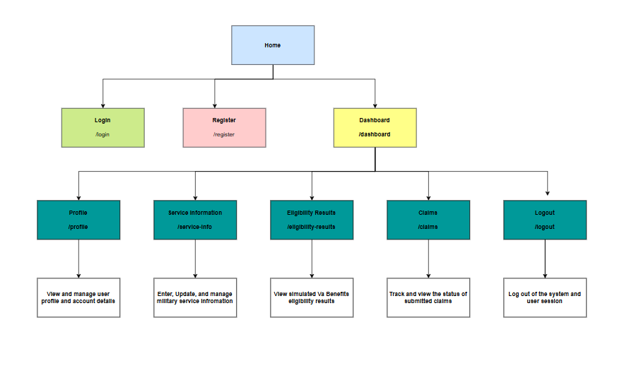
Sitemap Diagram:

The sitemap diagram illustrates the navigation structure of the VA Benefits Eligibility and Tracking System. The sitemap provides a high-level view of the application's pages and demonstrates how users navigate between system functions.
The application begins at the Home page, where users are presented with options to either log into an existing account or register a new account. Authentication serves as the gateway to protected application resources and ensures that only authorized users can access personalized information.
After successful authentication, users are directed to the Dashboard, which serves as the central navigation hub for the application. From the dashboard, users can access the primary system functions including profile management, service information management, eligibility results, and claim tracking.

Home Page
The Home Page serves as the entry point to the application and provides general information about the system along with navigation options for login and registration.

Login and Registration Pages
The Login and Registration pages support account creation and authentication. These pages allow users to establish credentials and gain access to system functionality.

Dashboard
The Dashboard functions as the primary landing page after authentication. It provides users with an overview of their information and serves as the central navigation point for all major application features.

Profile Page
The Profile page allows users to view and manage account-related information. Users may review personal details and update account information as needed.

Service Information Page
The Service Information page allows users to enter and maintain military service details that are used by the eligibility determination process.

Eligibility Results Page
The Eligibility Results page displays simulated benefit eligibility determinations generated by the application based on the user's submitted service information.

Claims Page
The Claims page provides access to claim tracking functionality and allows users to review the status of claims associated with their account.

Logout Function
The Logout function terminates the active user session and returns the application to its initial state.

Sitemap Design Summary
The sitemap was designed to provide a simple and intuitive navigation structure that minimizes complexity while supporting all required system functionality. The dashboard-centered navigation model allows users to quickly access the most important application features while maintaining a logical and organized user experience.

User Interface Diagrams:
The user interface design was developed to provide a simple, intuitive, and user-friendly experience for veterans and other users seeking information regarding benefit eligibility and claim tracking. The interface follows a dashboard-centered navigation model that allows users to quickly access the system's primary functions while maintaining a consistent layout throughout the application.
The following wireframes illustrate the planned user interface design for the VA Benefits Eligibility and Tracking System.

Figure 6. Login Page Wireframe
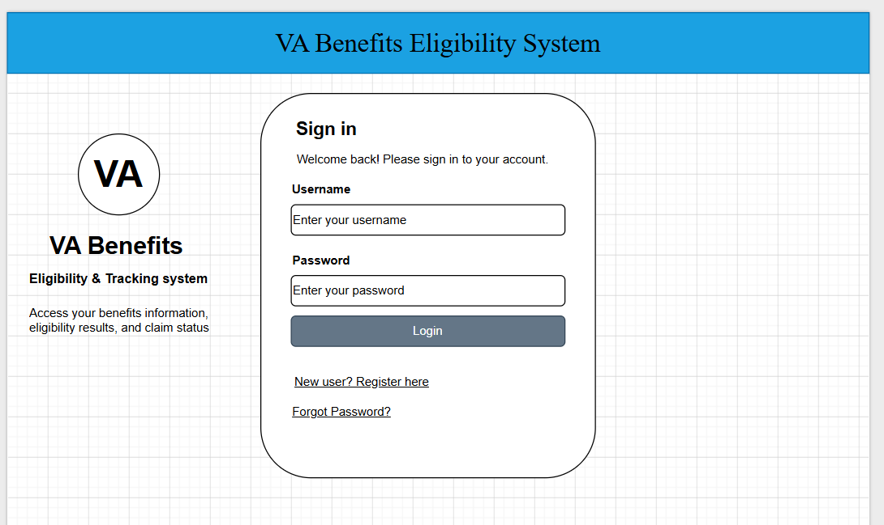
The Login Page serves as the primary authentication interface for returning users. Users enter their username and password to gain access to the application. Links are also provided to support new user registration and password recovery functionality.
Key features include:
- Username field
- Password field
- Login button
- Registration link
- Forgot Password option

Figure 7. Registration Page Wireframe
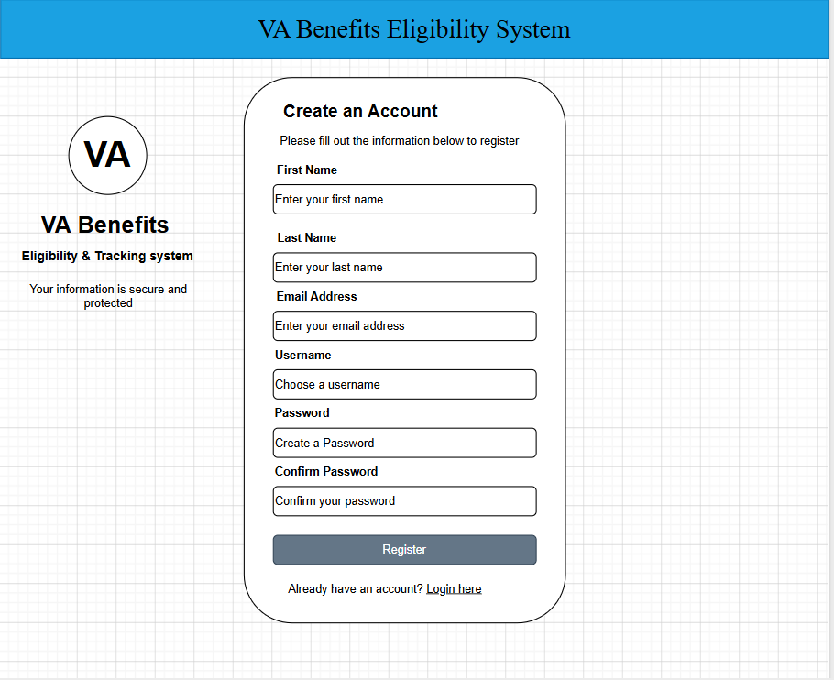The Registration Page allows new users to create an account within the system. Required information includes personal identification and account credentials necessary for future authentication.
Key features include:
- First Name field
- Last Name field
- Email Address field
- Username field
- Password field
- Confirm Password field
- Registration button

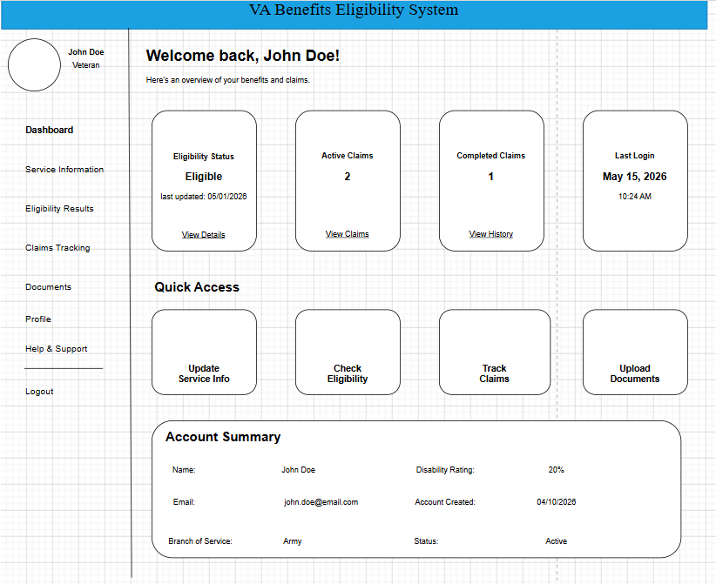
Figure 8. Dashboard Wireframe
The Dashboard serves as the central navigation hub following successful authentication. This page provides users with a summary of account information and direct access to the application's major features.
Key features include:
- Welcome message
- Navigation menu
- Eligibility summary
- Claim status summary
- Quick access links

Figure 9. Service Information Page Wireframe
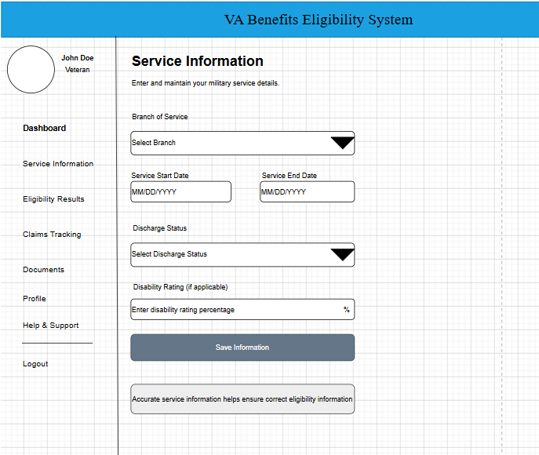The Service Information page allows users to enter and maintain military service details used during the eligibility determination process.
Key features include:
- Branch of Service selection
- Service Start Date
- Service End Date
- Discharge Status selection
- Disability Rating field
- Save Information button

Figure 10. Eligibility Results Page Wireframe
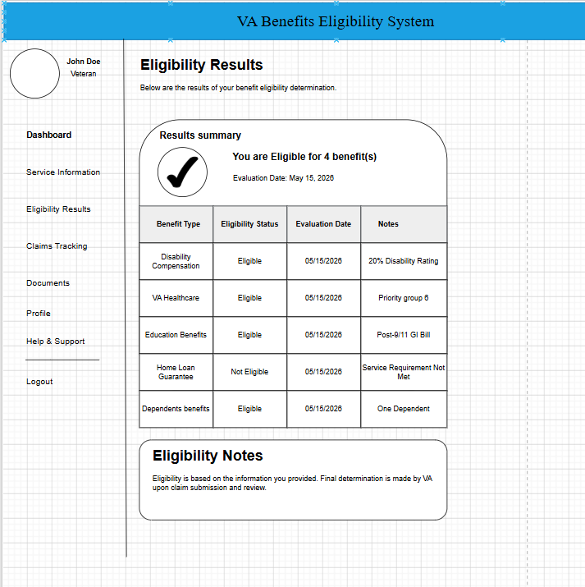The Eligibility Results page displays simulated benefit determinations generated from the user's submitted military service information.
Key features include:
- Benefit Type
- Eligibility Status
- Evaluation Date
- Eligibility Notes
- Results Summary

Figure 11. Claims Tracking Page Wireframe
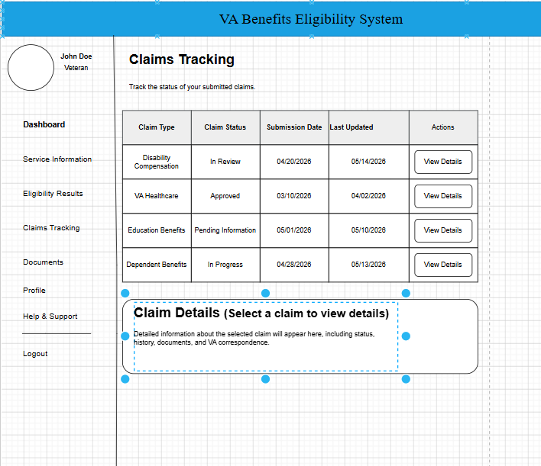The Claims Tracking page allows users to monitor claim information and review current claim statuses.
Key features include:
- Claim Type
- Claim Status
- Submission Date
- Last Updated Date
- Claim Details

User Interface Design Considerations
Several design principles were incorporated into the user interface architecture:
- Consistent navigation across all screens
- Clear visual hierarchy
- Responsive design considerations
- Accessibility-focused layout
- Minimal user input complexity
- Dashboard-centered navigation structure
The interface was designed to reduce user confusion while supporting efficient completion of common tasks such as updating service information, reviewing eligibility results, and monitoring claims.

User Interface Design Summary
The planned user interface provides a structured and intuitive experience that aligns with the functional requirements of the system. The wireframes serve as a blueprint for implementation and establish a consistent design standard that will guide frontend development during future project phases.

UML Diagrams:
Unified Modeling Language (UML) diagrams were developed to model the structure and behavior of the VA Benefits Eligibility and Tracking System. These diagrams provide a visual representation of system components, object relationships, and interactions between users and application services.

Figure 12. UML Class Diagram
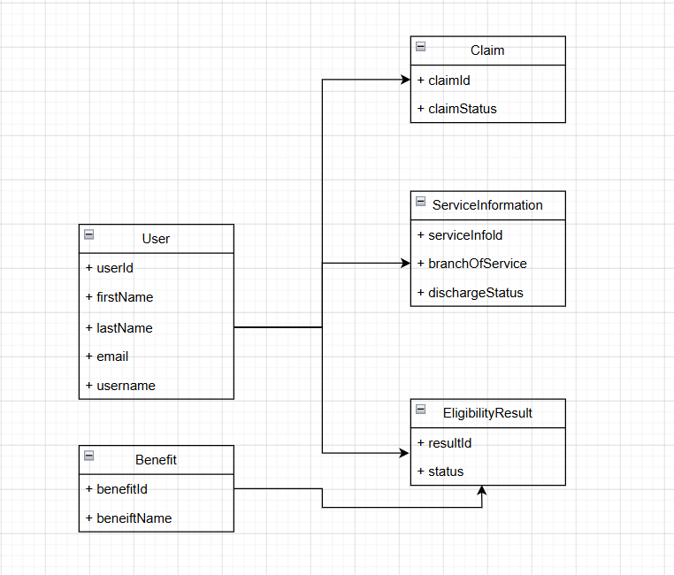The UML Class Diagram represents the primary classes within the system and the relationships between those classes. The design aligns with the database structure and identifies the key entities that support system functionality.
Major classes include:
- User
- ServiceInformation
- Benefit
- EligibilityResult
- Claim
The User class serves as the central entity and maintains relationships with service information records, eligibility evaluations, and claims. The Benefit class defines available benefit categories, while the EligibilityResult class stores evaluation outcomes generated by the eligibility determination process.
The class diagram serves as a blueprint for the application's domain model and will guide entity creation during implementation.

Figure 13. User Login Sequence Diagram
The User Login Sequence Diagram illustrates the interactions that occur when a user authenticates with the system.
The login process follows these steps:
- User enters login credentials.
- Login request is submitted to the application.
- Authentication service validates credentials.
- User account information is retrieved from the database.
- Credentials are verified.
- Authentication result is returned.
- User is redirected to the dashboard upon successful login.
This sequence diagram demonstrates the flow of information between the user interface, application services, and database during authentication.

Figure 14. Eligibility Evaluation Sequence Diagram
The Eligibility Evaluation Sequence Diagram illustrates the process used to generate simulated benefit eligibility determinations.
The process follows these steps:
- User submits military service information.
- Application validates submitted data.
- Eligibility service retrieves applicable benefit criteria.
- Eligibility rules are executed.
- Eligibility results are generated.
- Results are stored in the database.
- Results are returned to the dashboard for display.
This sequence diagram demonstrates how business logic components interact to process user information and produce eligibility determinations.

UML Design Considerations
The UML diagrams were designed to support both system analysis and implementation activities. The class diagram provides a structural view of system entities and relationships, while the sequence diagrams model dynamic interactions between system components.
Together, these diagrams provide developers with a clear understanding of system architecture, object relationships, and operational workflows before implementation begins.

UML Design Summary
The UML diagrams establish a visual representation of the application's structure and behavior. These artifacts support software development by documenting how data is organized, how components interact, and how major system processes are executed throughout the application lifecycle.

Service API Design:
The VA Benefits Eligibility and Tracking System will utilize RESTful web services to facilitate communication between the user interface and backend application components. The API design follows standard REST principles and uses JSON as the primary data exchange format. These services support user authentication, service information management, eligibility determination, and claim tracking functionality.

API Design Standards
Standard | Description
Protocol | HTTP/HTTPS
Data Format | JSON
Architecture Style | REST
Authentication | Session-Based Authentication (Planned)
Character Encoding | UTF-8
Response Format | JSON Objects

Authentication API

User Registration
Endpoint
POST /api/auth/register
Description
Creates a new user account.

Request Body
{
"firstName": "John",
"lastName": "Doe",
"email": "john.doe@email.com",
"username": "johndoe",
"password": "Password123"
}

Successful Response
{
"message": "User registered successfully",
"userId": 1
}

User Login
Endpoint
POST /api/auth/login
Description
Authenticates a user and grants access to protected application resources.

Request Body
{
"username": "johndoe",
"password": "Password123"
}

Successful Response
{
"message": "Login successful",
"userId": 1
}

User Profile API

Retrieve User Profile
Endpoint
GET /api/users/{userId}

Successful Response
{
"userId": 1,
"firstName": "John",
"lastName": "Doe",
"email": "john.doe@email.com",
"username": "johndoe"
}

Service Information API

Submit Service Information
Endpoint
POST /api/service-information

Request Body
{
"userId": 1,
"branchOfService": "Army",
"serviceStartDate": "2010-01-01",
"serviceEndDate": "2018-01-01",
"dischargeStatus": "Honorable",
"disabilityRating": 30
}

Successful Response
{
"message": "Service information saved successfully"
}

Retrieve Service Information
Endpoint
GET /api/service-information/{userId}

Successful Response
{
"serviceInfoId": 5,
"branchOfService": "Army",
"serviceStartDate": "2010-01-01",
"serviceEndDate": "2018-01-01",
"dischargeStatus": "Honorable",
"disabilityRating": 30
}

Eligibility API

Evaluate Eligibility
Endpoint
POST /api/eligibility/evaluate

Description
Processes military service information and generates simulated VA benefit eligibility results.

Request Body
{
"userId": 1
}

Successful Response
{
"benefitType": "Disability Compensation",
"eligibilityStatus": "Eligible",
"evaluationDate": "2026-06-15"
}

Retrieve Eligibility Results
Endpoint
GET /api/eligibility/{userId}

Successful Response
{
"eligibilityResults": [
{
"benefitType": "Disability Compensation",
"eligibilityStatus": "Eligible"
},
{
"benefitType": "Education Benefits",
"eligibilityStatus": "Eligible"
}
]
}

Claim Tracking API

Retrieve Claims
Endpoint
GET /api/claims/{userId}

Successful Response
{
"claims": [
{
"claimId": 101,
"claimType": "Disability Claim",
"claimStatus": "Under Review",
"submissionDate": "2026-05-01"
}
]
}

Create Claim
Endpoint
POST /api/claims

Request Body
{
"userId": 1,
"claimType": "Disability Claim"
}

Successful Response
{
"message": "Claim created successfully",
"claimId": 101
}

HTTP Response Codes
Code | Description
200 | Request Successful
201 | Resource Created Successfully
400 | Invalid Request Data
401 | Unauthorized Access
404 | Resource Not Found
500 | Internal Server Error

API Security Considerations
The planned API design incorporates several security measures including authentication controls, input validation, secure password storage, and restricted access to protected resources. Sensitive information such as passwords will never be returned in API responses. Future enhancements may include token-based authentication and HTTPS deployment for encrypted communication.

API Design Summary
The RESTful API architecture provides a standardized method for communication between application components while supporting future scalability and maintainability. The proposed endpoints align with the functional requirements of the VA Benefits Eligibility and Tracking System and provide a foundation for future implementation during the development phase.

NFR’s (Security Design, etc.):
The VA Benefits Eligibility and Tracking System has been designed to satisfy a variety of non-functional requirements that support security, performance, reliability, maintainability, scalability, and usability. Although the application uses simulated VA data and is intended for educational purposes, industry-standard design principles have been incorporated to ensure the system remains secure, efficient, and maintainable.

Security Design
Security is a critical component of the system design. The application will implement authentication and access controls to ensure that only authorized users can access protected resources. User passwords will be stored using BCrypt hashing rather than plain-text storage, reducing the risk of credential compromise. Input validation will be performed on both client-side and server-side components to reduce the likelihood of invalid data entry and common web application attacks.
Planned security controls include:
- User authentication and authorization
- BCrypt password encryption
- Input validation and sanitization
- Session management controls
- Restricted access to protected resources
- Secure handling of user-submitted information
Although the application will not process real VA records, these controls align with industry best practices for web application security.

Performance Design
The system is designed to provide responsive performance for expected user workloads. The layered architecture promotes efficient processing by separating presentation, business logic, and data access responsibilities. Database indexing on primary and foreign key fields will improve query performance and reduce retrieval times.
Performance objectives include:
- Fast page load times
- Efficient database queries
- Responsive user interactions
- Minimal resource consumption
- Support for concurrent user access during testing
Because the application is intended for a limited number of users, no specialized performance optimization techniques are currently required.

Reliability Design
Reliability requirements focus on ensuring that the system consistently performs its intended functions. Error handling mechanisms will be incorporated throughout the application to manage invalid inputs, database exceptions, and unexpected application conditions.
Reliability features include:
- Exception handling
- Data validation
- Database integrity constraints
- Controlled transaction processing
- Consistent application behavior
These measures help reduce application failures and improve overall system stability.

Availability Design
The system will be designed to remain available whenever the hosting environment is operational. During development and testing, the application will run within a controlled environment using Spring Boot and MySQL.
Availability considerations include:
- Stable application deployment environment
- Reliable database connectivity
- Graceful error handling
- Controlled startup and shutdown procedures
Future deployments could leverage cloud-hosted infrastructure to further improve system availability.

Maintainability Design
Maintainability was a primary consideration during system design. The application utilizes a layered architecture that separates presentation, business logic, and data access responsibilities. This approach simplifies future modifications and reduces dependencies between components.
Maintainability features include:
- Modular system architecture
- Consistent coding standards
- UML documentation
- API documentation
- Database documentation
- Source code version control using GitLab
These practices support easier troubleshooting, testing, and future enhancement efforts.

Scalability Design
Although the project scope is limited to a capstone implementation, the architecture supports future growth. The separation of application components allows additional features and services to be added with minimal disruption to existing functionality.
Potential scalability enhancements include:
- Cloud deployment
- Load balancing
- Database optimization
- Microservice migration
- Containerization using Docker
The current design provides a foundation capable of supporting future expansion if additional functionality is required.

Usability Design
The user interface was designed with simplicity and accessibility in mind. Navigation is centered around a dashboard that provides quick access to the system's primary functions. Consistent layouts and clearly labeled controls help reduce the learning curve for new users.
Usability objectives include:
- Intuitive navigation
- Consistent page layouts
- Clear user feedback
- Minimal data entry complexity
- Responsive interface design
These design principles support a positive user experience and improve overall system effectiveness.

NFR Compliance Summary
The system architecture incorporates security, performance, reliability, availability, maintainability, scalability, and usability considerations throughout the design process. These non-functional requirements complement the system's functional capabilities and provide a framework for developing a secure, stable, and user-friendly application. By addressing these quality attributes during the design phase, the project establishes a strong foundation for successful implementation and future growth.

Operational Support Design:
The operational support design for the VA Benefits Eligibility and Tracking System establishes the processes and tools required to monitor application performance, manage system errors, support troubleshooting activities, and maintain overall system stability. Although the project is being developed as an academic capstone project, operational considerations were incorporated into the design to reflect industry best practices and support future expansion.

Application Logging
Application logging will be implemented to record significant system events, user activities, and application errors. Logging provides developers and administrators with visibility into system behavior and assists with troubleshooting and performance analysis.
The application will utilize Spring Boot's built-in logging framework to record information such as:
- User login attempts
- User registration events
- Service information submissions
- Eligibility evaluation requests
- Claim creation and updates
- Application startup and shutdown events
- System errors and exceptions
Log files will be stored locally during development and testing to support debugging and issue resolution.

Error Handling and Exception Management
The application design includes centralized exception handling to improve system stability and user experience. Unexpected errors will be captured and logged while presenting user-friendly error messages through the interface.
Error management objectives include:
- Preventing application crashes
- Providing meaningful error messages
- Recording detailed technical information in log files
- Supporting efficient troubleshooting
- Protecting sensitive system information from exposure
This approach helps maintain system reliability while simplifying issue diagnosis.

System Monitoring
System monitoring activities will focus on observing application health and identifying operational issues before they affect users.
Key monitoring areas include:
- Application availability
- Database connectivity
- Response times
- Resource utilization
- Error frequency
- Authentication failures
During development, monitoring will primarily be performed through application logs and development tools. Future production deployments could incorporate dedicated monitoring platforms for enhanced visibility.

Audit Trail Support
The system design supports basic audit capabilities through database records and application logs. Audit information may include:
- Account creation dates
- User login activity
- Service information updates
- Eligibility evaluation timestamps
- Claim status changes
Maintaining an audit trail improves accountability and provides historical records of significant system activities.

Backup and Recovery Considerations
Although the capstone project will operate in a development environment, database backup procedures are included as part of the operational design.
Backup considerations include:
- Periodic database exports
- Source code version control through GitLab
- Recovery of application configuration files
- Preservation of project documentation
These practices help reduce the risk of data loss and support system recovery when necessary.

Version Control and Change Management
GitLab will serve as the primary version control platform for the project. All source code, documentation, and configuration changes will be tracked through repository commits and version history.
Benefits of version control include:
- Change tracking
- Collaboration support
- Rollback capability
- Branch management
- Release management
Version control practices improve maintainability and provide a documented history of project development.

Troubleshooting Procedures
Operational support activities will follow a structured troubleshooting process when issues occur.
Typical troubleshooting steps include:
- Review application log files.
- Identify error messages and exception details.
- Verify database connectivity.
- Validate application configuration settings.
- Test affected functionality.
- Apply corrective actions.
- Retest system functionality.
This process supports efficient problem resolution and minimizes system downtime.

Operational Support Summary
The operational support design provides a framework for monitoring, maintaining, and troubleshooting the VA Benefits Eligibility and Tracking System. Through logging, error handling, audit tracking, backup procedures, and version control practices, the design promotes reliability, maintainability, and long-term system stability. These operational considerations ensure that the application can be effectively supported throughout its lifecycle and provide a foundation for future production deployment.

Other Documentation:
The development of the VA Benefits Eligibility and Tracking System has been supported by a variety of project management, requirements analysis, and design artifacts created throughout the capstone project lifecycle. These documents provide additional context regarding project scope, system requirements, implementation planning, and overall project organization.

Project Requirements Documentation
Requirements documentation developed during earlier project phases served as the foundation for the system design. These artifacts include functional requirements, non-functional requirements, technical requirements, user stories, and use case descriptions. Collectively, these documents establish the business objectives and operational expectations that guided architectural and technical design decisions.

User Stories and Iteration Planning
User stories were developed to define system functionality from the perspective of end users. These stories were organized into planned development iterations to support incremental implementation throughout the project lifecycle.
Major user story categories include:
- User registration and authentication
- Military service information management
- Eligibility determination processing
- Claim tracking functionality
- Dashboard and reporting capabilities
These user stories provide a roadmap for implementation and help ensure that development activities remain aligned with stakeholder expectations.

Project Schedule and Milestones
Project milestones were established to guide project execution and track progress throughout the capstone course. Major milestones include project proposal development, requirements analysis, architecture and design activities, implementation, testing, and final project delivery.
The milestone-based approach supports effective project management by dividing development activities into manageable phases with clearly defined objectives and deliverables.

GitLab Project Management
GitLab is being utilized as the primary platform for source code management and project organization. GitLab supports version control, issue tracking, milestone management, and documentation storage throughout the development process.
Planned GitLab management activities include:
- Source code version control
- Issue tracking
- Task management
- Milestone tracking
- Documentation management
The use of GitLab promotes organization, traceability, and efficient project management practices.

Design Artifacts
Several design artifacts were developed during the planning and design phases of the project, including:
- System Architecture Diagram
- Logical Solution Design Diagram
- Physical Deployment Diagram
- Activity Diagram
- Sitemap Diagram
- Entity Relationship Diagram (ERD)
- User Interface Wireframes
- UML Class Diagram
- UML Sequence Diagrams
- API Design Documentation
These artifacts provide a comprehensive representation of the system and serve as implementation references during development.

Future Documentation
Additional documentation may be developed during implementation and testing phases, including:
- Test plans
- Test cases
- User guides
- Installation documentation
- Deployment instructions
- Maintenance documentation
These documents will further support system operation and future enhancement activities.

Documentation Summary
The supporting documentation created throughout the capstone project provides a complete record of project planning, requirements analysis, architecture design, technical design, and project management activities. Together, these artifacts establish a clear roadmap for implementation and support the successful completion of the VA Benefits Eligibility and Tracking System.

Appendix A – Technical Issue and Risk Log
Issue or Risk | Description | Project Impact | Action Plan/Resolution | Owner | Importance | Date Entered | Date to Review | Date Resolved
Risk | Scope expansion beyond planned project requirements | May increase development time and delay project completion | Maintain focus on approved requirements and defer additional features to future enhancements | Project Developer | High | 06/15/2026 | Weekly | Open
Risk | Delays during implementation phase due to unforeseen technical challenges | May impact project schedule and milestone completion dates | Follow incremental development approach and address issues early through testing and research | Project Developer | High | 06/15/2026 | Weekly | Open
Risk | Integration issues between application components and database | Could prevent proper system functionality and delay testing | Develop and test database connectivity early in implementation phase | Project Developer | Medium | 06/15/2026 | Weekly | Open
Risk | Authentication and security implementation complexity | Could introduce vulnerabilities or require additional development effort | Follow Spring Security best practices and perform security testing throughout development | Project Developer | High | 06/15/2026 | Weekly | Open
Risk | Incomplete or inconsistent test coverage | Defects may remain undetected prior to final deployment | Develop test cases for all major functional requirements and perform comprehensive testing | Project Developer | Medium | 06/15/2026 | Weekly | Open
Issue | Limited project timeline for implementation and testing | May reduce time available for refinement and enhancements | Prioritize core functionality and maintain milestone schedule | Project Developer | High | 06/15/2026 | Weekly | Open
Risk | Database design changes during development | May require updates to code, APIs, and documentation | Finalize database structure before implementation begins and control design changes | Project Developer | Medium | 06/15/2026 | Weekly | Open
Risk | User interface modifications required after development begins | May increase rework effort and affect project schedule | Utilize approved wireframes and maintain design consistency during implementation | Project Developer | Low | 06/15/2026 | Weekly | Open

Appendix A Summary
The Technical Issue and Risk Log is used to identify, monitor, and mitigate potential project risks throughout the development lifecycle. Risks will be reviewed regularly during implementation to ensure timely corrective action and minimize impacts to project scope, schedule, quality, and overall success.

Appendix B – References

References
Spring Boot. (2026). Spring Boot Reference Documentation. Retrieved June 15, 2026, from Spring Boot Documentation
Oracle MySQL Documentation. (2026). MySQL Reference Manual. Oracle Corporation.
GitLab Documentation. (2026). GitLab Documentation. GitLab Inc.
Apache Maven. (2026). Apache Maven Project Documentation. Retrieved June 15, 2026, from Apache Maven Documentation
Fielding, R. T. (2000). Architectural styles and the design of network-based software architectures (Doctoral dissertation, University of California, Irvine).
Pressman, R. S., & Maxim, B. R. (2020). Software engineering: A practitioner's approach (9th ed.). McGraw-Hill Education.
Sommerville, I. (2016). Software engineering (10th ed.). Pearson.
Object Management Group. (2026). Unified Modeling Language (UML) Specification. Retrieved June 15, 2026, from OMG UML Specification
OWASP Foundation. (2026). OWASP Top 10 Web Application Security Risks. Retrieved June 15, 2026, from OWASP Top 10

Appendix C – External Resources
GIT URL: | The GIT URL (if applicable).
Hosting URL: | The Hosting URL (if applicable).

